1 run

training 1 epoch...

26.514798641204834 seconds used......

1 training finished! average train loss: 0.8882840852204122

evaluating...

Confusion matrix, without normalization

[[ 46 2 5]

[ 77 96 8]

[104 8 121]]

Normalized confusion matrix

[[0.86792453 0.03773585 0.09433962]

[0.42541436 0.53038674 0.0441989 ]

[0.44635193 0.03433476 0.5193133 ]]

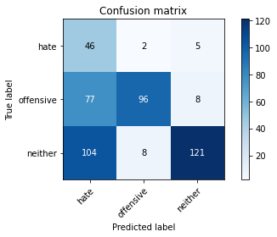

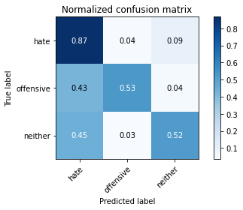

precision recall f1-score support

hate 0.20 0.87 0.33 53

offensive 0.91 0.53 0.67 181

neither 0.90 0.52 0.66 233

accuracy 0.56 467

macro avg 0.67 0.64 0.55 467

weighted avg 0.82 0.56 0.63 467

average eval_loss: 0.877679410080115, accuracy: 0.563169164882227

training 2 epoch...

28.549848794937134 seconds used......

2 training finished! average train loss: 0.6248432962517989

evaluating...

Confusion matrix, without normalization

[[ 19 17 17]

[ 30 132 19]

[ 23 21 189]]

Normalized confusion matrix

[[0.35849057 0.32075472 0.32075472]

[0.16574586 0.72928177 0.10497238]

[0.09871245 0.09012876 0.8111588 ]]

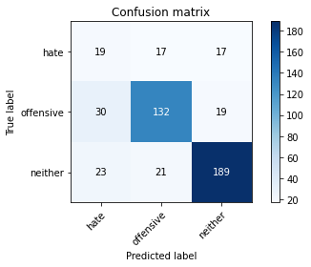

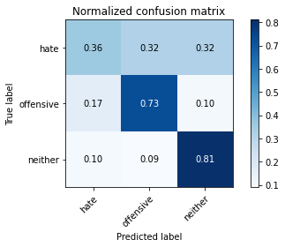

precision recall f1-score support

hate 0.26 0.36 0.30 53

offensive 0.78 0.73 0.75 181

neither 0.84 0.81 0.83 233

accuracy 0.73 467

macro avg 0.63 0.63 0.63 467

weighted avg 0.75 0.73 0.74 467

average eval_loss: 0.6049467734992504, accuracy: 0.728051391862955

training 3 epoch...

27.119046926498413 seconds used......

3 training finished! average train loss: 0.43600923705257866

evaluating...

Confusion matrix, without normalization

[[ 36 6 11]

[ 55 109 17]

[ 49 8 176]]

Normalized confusion matrix

[[0.67924528 0.11320755 0.20754717]

[0.3038674 0.60220994 0.09392265]

[0.21030043 0.03433476 0.75536481]]

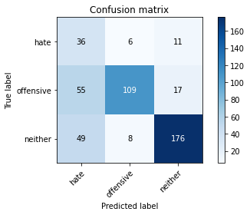

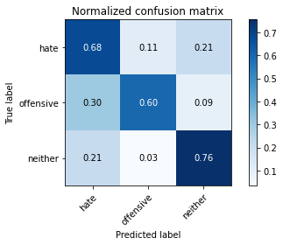

precision recall f1-score support

hate 0.26 0.68 0.37 53

offensive 0.89 0.60 0.72 181

neither 0.86 0.76 0.81 233

accuracy 0.69 467

macro avg 0.67 0.68 0.63 467

weighted avg 0.80 0.69 0.72 467

average eval_loss: 0.7673758529126644, accuracy: 0.6873661670235546

training 4 epoch...

27.12085485458374 seconds used......

4 training finished! average train loss: 0.2531132841188657

evaluating...

Confusion matrix, without normalization

[[ 29 8 16]

[ 49 105 27]

[ 29 7 197]]

Normalized confusion matrix

[[0.54716981 0.1509434 0.30188679]

[0.27071823 0.5801105 0.14917127]

[0.12446352 0.03004292 0.84549356]]

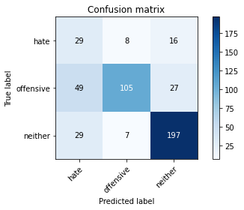

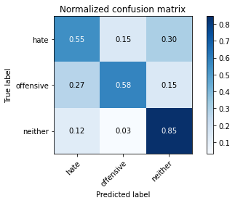

precision recall f1-score support

hate 0.27 0.55 0.36 53

offensive 0.88 0.58 0.70 181

neither 0.82 0.85 0.83 233

accuracy 0.71 467

macro avg 0.66 0.66 0.63 467

weighted avg 0.78 0.71 0.73 467

average eval_loss: 0.8686319552361965, accuracy: 0.708779443254818

training 5 epoch...

27.527426719665527 seconds used......

5 training finished! average train loss: 0.10578898529179002

evaluating...

Confusion matrix, without normalization

[[ 33 11 9]

[ 37 130 14]

[ 48 27 158]]

Normalized confusion matrix

[[0.62264151 0.20754717 0.16981132]

[0.20441989 0.71823204 0.07734807]

[0.20600858 0.11587983 0.67811159]]

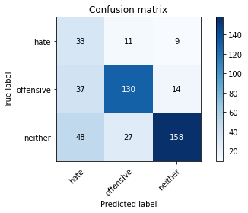

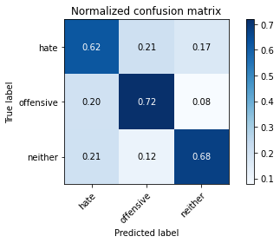

precision recall f1-score support

hate 0.28 0.62 0.39 53

offensive 0.77 0.72 0.74 181

neither 0.87 0.68 0.76 233

accuracy 0.69 467

macro avg 0.64 0.67 0.63 467

weighted avg 0.77 0.69 0.71 467

average eval_loss: 1.0551381583015125, accuracy: 0.6873661670235546

model of 1 epoch

Confusion matrix, without normalization

[[161 16 13]

[249 156 10]

[334 15 364]]

Normalized confusion matrix

[[0.84736842 0.08421053 0.06842105]

[0.6 0.37590361 0.02409639]

[0.4684432 0.02103787 0.51051893]]

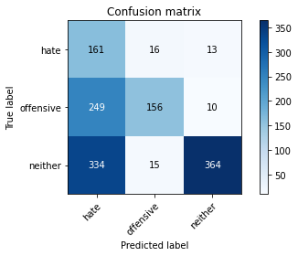

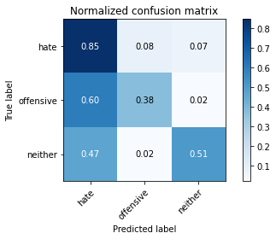

precision recall f1-score support

hate 0.22 0.85 0.34 190

offensive 0.83 0.38 0.52 415

neither 0.94 0.51 0.66 713

accuracy 0.52 1318

macro avg 0.66 0.58 0.51 1318

weighted avg 0.80 0.52 0.57 1318

average eval_loss: 0.9514432468197562, accuracy: 0.5166919575113809

0.5166919575113809

2 run

training 1 epoch...

15.4794340133667 seconds used......

1 training finished! average train loss: 0.9065262047868026

evaluating...

Confusion matrix, without normalization

[[ 28 8 17]

[ 58 109 14]

[ 45 21 167]]

Normalized confusion matrix

[[0.52830189 0.1509434 0.32075472]

[0.32044199 0.60220994 0.07734807]

[0.19313305 0.09012876 0.7167382 ]]

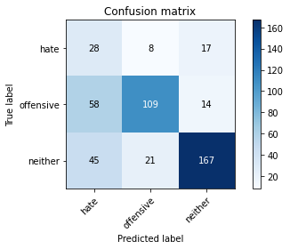

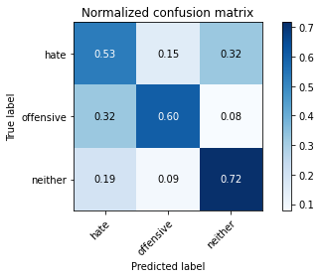

precision recall f1-score support

hate 0.21 0.53 0.30 53

offensive 0.79 0.60 0.68 181

neither 0.84 0.72 0.77 233

accuracy 0.65 467

macro avg 0.62 0.62 0.59 467

weighted avg 0.75 0.65 0.69 467

average eval_loss: 0.7625085910161337, accuracy: 0.6509635974304069

training 2 epoch...

14.637509107589722 seconds used......

2 training finished! average train loss: 0.6445662179275563

evaluating...

Confusion matrix, without normalization

[[ 28 9 16]

[ 41 125 15]

[ 36 18 179]]

Normalized confusion matrix

[[0.52830189 0.16981132 0.30188679]

[0.22651934 0.69060773 0.08287293]

[0.15450644 0.07725322 0.76824034]]

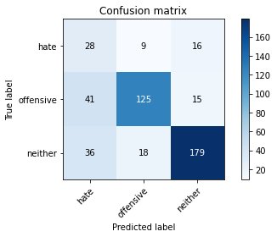

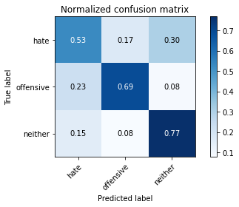

precision recall f1-score support

hate 0.27 0.53 0.35 53

offensive 0.82 0.69 0.75 181

neither 0.85 0.77 0.81 233

accuracy 0.71 467

macro avg 0.65 0.66 0.64 467

weighted avg 0.77 0.71 0.73 467

average eval_loss: 0.6913914233446121, accuracy: 0.7109207708779444

training 3 epoch...

14.62898302078247 seconds used......

3 training finished! average train loss: 0.45090804347082186

evaluating...

Confusion matrix, without normalization

[[ 35 9 9]

[ 50 119 12]

[ 57 14 162]]

Normalized confusion matrix

[[0.66037736 0.16981132 0.16981132]

[0.27624309 0.65745856 0.06629834]

[0.24463519 0.06008584 0.69527897]]

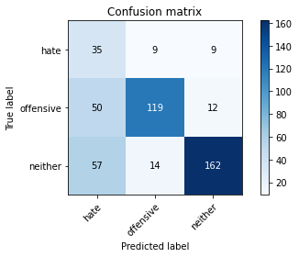

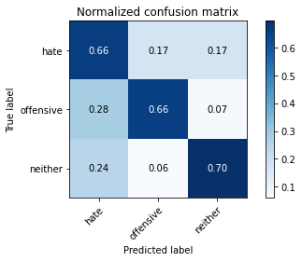

precision recall f1-score support

hate 0.25 0.66 0.36 53

offensive 0.84 0.66 0.74 181

neither 0.89 0.70 0.78 233

accuracy 0.68 467

macro avg 0.66 0.67 0.62 467

weighted avg 0.79 0.68 0.71 467

average eval_loss: 0.7953360167642435, accuracy: 0.6766595289079229

training 4 epoch...

14.674222707748413 seconds used......

4 training finished! average train loss: 0.2406762780523614

evaluating...

Confusion matrix, without normalization

[[ 27 13 13]

[ 35 131 15]

[ 36 21 176]]

Normalized confusion matrix

[[0.50943396 0.24528302 0.24528302]

[0.19337017 0.72375691 0.08287293]

[0.15450644 0.09012876 0.75536481]]

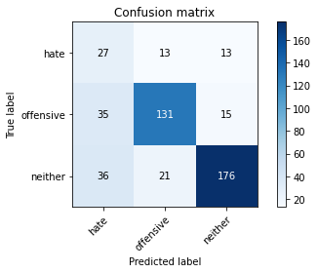

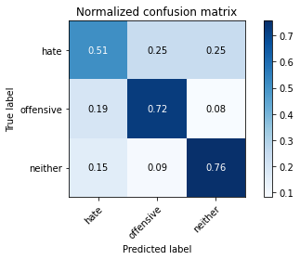

precision recall f1-score support

hate 0.28 0.51 0.36 53

offensive 0.79 0.72 0.76 181

neither 0.86 0.76 0.81 233

accuracy 0.72 467

macro avg 0.64 0.66 0.64 467

weighted avg 0.77 0.72 0.74 467

average eval_loss: 0.8237759284675121, accuracy: 0.715203426124197

training 5 epoch...

14.66247272491455 seconds used......

5 training finished! average train loss: 0.10821056103725966

evaluating...

Confusion matrix, without normalization

[[ 28 7 18]

[ 51 112 18]

[ 38 10 185]]

Normalized confusion matrix

[[0.52830189 0.13207547 0.33962264]

[0.28176796 0.61878453 0.09944751]

[0.16309013 0.04291845 0.79399142]]

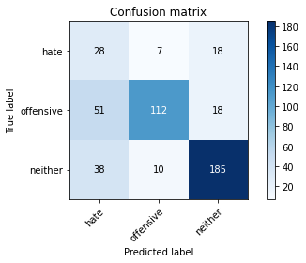

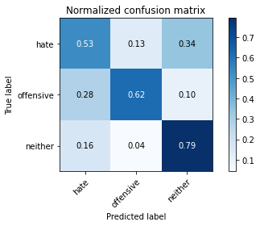

precision recall f1-score support

hate 0.24 0.53 0.33 53

offensive 0.87 0.62 0.72 181

neither 0.84 0.79 0.81 233

accuracy 0.70 467

macro avg 0.65 0.65 0.62 467

weighted avg 0.78 0.70 0.72 467

average eval_loss: 1.076973649362723, accuracy: 0.69593147751606

Confusion matrix, without normalization

[[137 34 19]

[143 250 22]

[227 28 458]]

Normalized confusion matrix

[[0.72105263 0.17894737 0.1 ]

[0.34457831 0.60240964 0.05301205]

[0.31837307 0.03927069 0.64235624]]

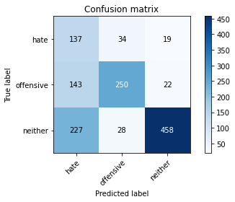

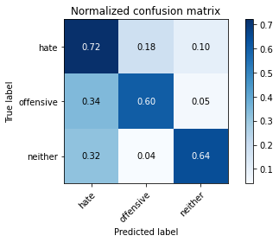

precision recall f1-score support

hate 0.27 0.72 0.39 190

offensive 0.80 0.60 0.69 415

neither 0.92 0.64 0.76 713

accuracy 0.64 1318

macro avg 0.66 0.66 0.61 1318

weighted avg 0.79 0.64 0.68 1318

average eval_loss: 0.8428617711320068, accuracy: 0.641122913505311

[18]:

0.641122913505311

3 run

training 1 epoch...

14.656577587127686 seconds used......

1 training finished! average train loss: 0.8776474720553348

evaluating...

Confusion matrix, without normalization

[[ 35 8 10]

[ 55 113 13]

[ 51 17 165]]

Normalized confusion matrix

[[0.66037736 0.1509434 0.18867925]

[0.3038674 0.62430939 0.0718232 ]

[0.21888412 0.07296137 0.70815451]]

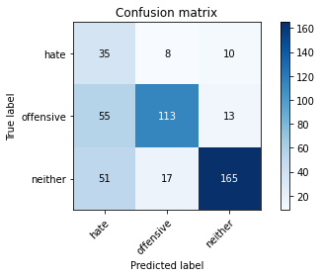

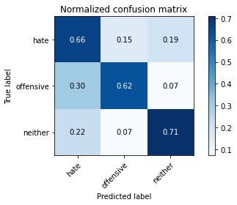

precision recall f1-score support

hate 0.25 0.66 0.36 53

offensive 0.82 0.62 0.71 181

neither 0.88 0.71 0.78 233

accuracy 0.67 467

macro avg 0.65 0.66 0.62 467

weighted avg 0.78 0.67 0.71 467

average eval_loss: 0.7232243729134401, accuracy: 0.6702355460385439

training 2 epoch...

14.599119186401367 seconds used......

2 training finished! average train loss: 0.6298590137770301

evaluating...

Confusion matrix, without normalization

[[ 40 5 8]

[ 69 98 14]

[ 68 9 156]]

Normalized confusion matrix

[[0.75471698 0.09433962 0.1509434 ]

[0.38121547 0.54143646 0.07734807]

[0.29184549 0.03862661 0.6695279 ]]

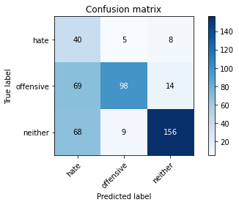

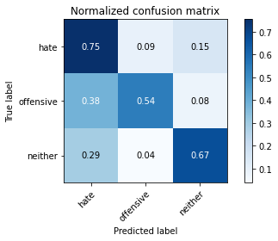

precision recall f1-score support

hate 0.23 0.75 0.35 53

offensive 0.88 0.54 0.67 181

neither 0.88 0.67 0.76 233

accuracy 0.63 467

macro avg 0.66 0.66 0.59 467

weighted avg 0.80 0.63 0.68 467

average eval_loss: 0.7772128582000732, accuracy: 0.6295503211991434

training 3 epoch...

14.672150135040283 seconds used......

3 training finished! average train loss: 0.4205208340365636

evaluating...

Confusion matrix, without normalization

[[ 26 6 21]

[ 62 97 22]

[ 28 6 199]]

Normalized confusion matrix

[[0.49056604 0.11320755 0.39622642]

[0.34254144 0.5359116 0.12154696]

[0.12017167 0.02575107 0.85407725]]

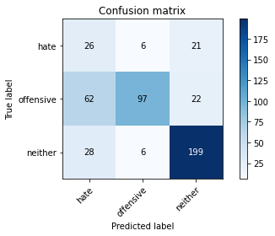

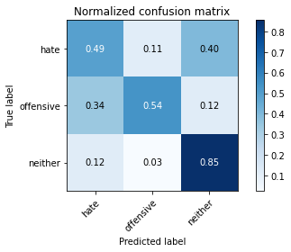

precision recall f1-score support

hate 0.22 0.49 0.31 53

offensive 0.89 0.54 0.67 181

neither 0.82 0.85 0.84 233

accuracy 0.69 467

macro avg 0.65 0.63 0.60 467

weighted avg 0.78 0.69 0.71 467

average eval_loss: 0.7475283779203892, accuracy: 0.6895074946466809

training 4 epoch...

14.612759590148926 seconds used......

4 training finished! average train loss: 0.24287916955194974

evaluating...

Confusion matrix, without normalization

[[ 16 14 23]

[ 26 135 20]

[ 19 17 197]]

Normalized confusion matrix

[[0.30188679 0.26415094 0.43396226]

[0.14364641 0.74585635 0.11049724]

[0.08154506 0.07296137 0.84549356]]

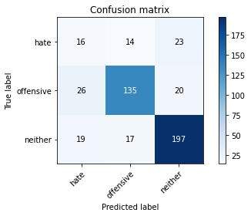

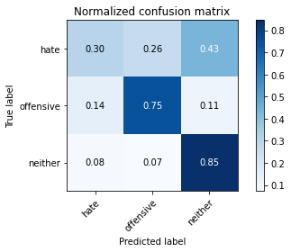

precision recall f1-score support

hate 0.26 0.30 0.28 53

offensive 0.81 0.75 0.78 181

neither 0.82 0.85 0.83 233

accuracy 0.75 467

macro avg 0.63 0.63 0.63 467

weighted avg 0.75 0.75 0.75 467

average eval_loss: 0.8101793738702933, accuracy: 0.7451820128479657

training 5 epoch...

14.627277851104736 seconds used......

5 training finished! average train loss: 0.0961904609943495

evaluating...

Confusion matrix, without normalization

[[ 21 12 20]

[ 36 125 20]

[ 30 14 189]]

Normalized confusion matrix

[[0.39622642 0.22641509 0.37735849]

[0.19889503 0.69060773 0.11049724]

[0.12875536 0.06008584 0.8111588 ]]

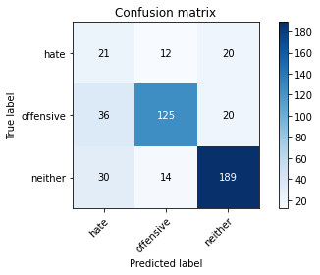

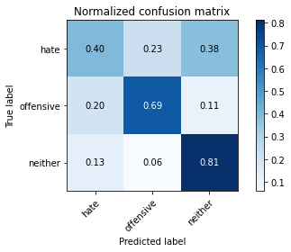

precision recall f1-score support

hate 0.24 0.40 0.30 53

offensive 0.83 0.69 0.75 181

neither 0.83 0.81 0.82 233

accuracy 0.72 467

macro avg 0.63 0.63 0.62 467

weighted avg 0.76 0.72 0.73 467

average eval_loss: 0.9694812235732874, accuracy: 0.7173447537473233

Confusion matrix, without normalization

[[154 13 23]

[214 176 25]

[238 11 464]]

Normalized confusion matrix

[[0.81052632 0.06842105 0.12105263]

[0.51566265 0.42409639 0.06024096]

[0.33380084 0.01542777 0.65077139]]

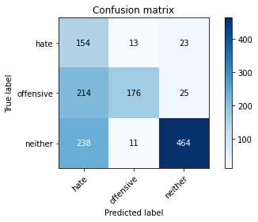

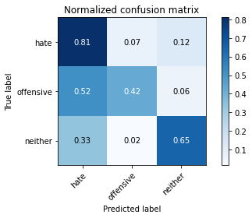

precision recall f1-score support

hate 0.25 0.81 0.39 190

offensive 0.88 0.42 0.57 415

neither 0.91 0.65 0.76 713

accuracy 0.60 1318

macro avg 0.68 0.63 0.57 1318

weighted avg 0.80 0.60 0.65 1318

average eval_loss: 0.8533571737282204, accuracy: 0.6024279210925645

[20]:

0.6024279210925645